Build an Agentic AI System in .NET 8 Using OpenAI and C#
Introduction
Most of us have already used Generative AI tools that respond to prompts — they write code, summarize text, or generate SQL when asked.
But the next evolution is Agentic AI.
Agentic AI doesn’t just respond — it plans, decides, and executes tasks to achieve a goal.
Instead of:
- “Tell me what’s wrong.”
You assign:
- “Investigate failures and fix them.”
The AI becomes a digital worker embedded inside your system.
This article walks through building a real-world Agentic AI Proof of Concept using:
- .NET 8 Web API
- SQL Server
- Semantic Kernel
- Background Services
- OpenAI (LLM)
We will create an Autonomous Order Reconciliation Agent that detects and fixes failed orders automatically.
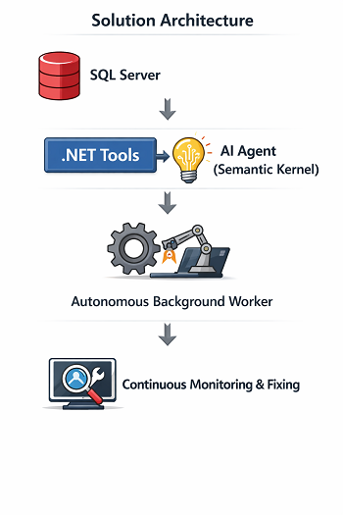
Step 1 — Basic Setup (.NET + SQL Server)
Create a new Web API project:
- dotnet new webapi -n OrderAgentPOC
- cd OrderAgentPOC
Install required packages:
- dotnet add package Dapper
- dotnet add package Microsoft.Data.SqlClient
- dotnet add package Serilog.AspNetCore
Configure Database Connection
appsettings.json
"ConnectionStrings": {
"DefaultConnection": "Server=localhost;Database=OrderAgentPOC;Trusted_Connection=True;TrustServerCertificate=True;"
}
Create Database
CREATE DATABASE OrderAgentPOC;
GO CREATE TABLE Orders
(
Id INT IDENTITY PRIMARY KEY,
OrderNumber NVARCHAR(50),
Amount DECIMAL(10,2),
Tax DECIMAL(10,2) NULL,
Status NVARCHAR(50),
CreatedDate DATETIME DEFAULT GETDATE()
);

INSERT INTO Orders (OrderNumber, Amount, Tax, Status)
VALUES
('ORD-1001', 1000, NULL, 'Failed'),
('ORD-1002', 500, 50, 'Completed'),
('ORD-1003', 750, NULL, 'Failed');

These failed rows simulate real reconciliation issues.
Create DB Connection Factory
public class DbConnectionFactory
{
private readonly IConfiguration _configuration;
public DbConnectionFactory(IConfiguration configuration)
{
_configuration = configuration;
}
public IDbConnection CreateConnection()
=> new SqlConnection(_configuration.GetConnectionString("DefaultConnection"));
}
Step 2 — Tools + DB Simulation (Expose System Actions to AI)
Agentic AI works through Tools.
Think of tools as:
  - Functions the AI can call to interact with your system.
- Create AI Tools

public class OrderAgentTools
{
private readonly DbConnectionFactory _factory;
public OrderAgentTools(DbConnectionFactory factory)
{
_factory = factory;
}

[KernelFunction, Description("Get failed orders")]
public async Task<string> GetFailedOrders()
{
using var conn = _factory.CreateConnection();
var orders = await conn.QueryAsync( "SELECT Id, OrderNumber, Amount, Tax FROM Orders WHERE Status='Failed'");
return JsonSerializer.Serialize(orders);
}

[KernelFunction, Description("Fix missing tax")]
public async Task<string> FixMissingTax(int orderId)
{
using var conn = _factory.CreateConnection();
await conn.ExecuteAsync(@" UPDATE Orders SET Tax = Amount * 0.18, Status = 'Completed' WHERE Id = @Id",
new { Id = orderId });
return $"Order {orderId} fixed.";
}
}

These methods are now AI-callable actions.
Step 3 — Agent Integration (Add Reasoning)
Install Semantic Kernel:
- dotnet add package Microsoft.SemanticKernel
- dotnet add package Microsoft.SemanticKernel.Connectors.OpenAI
Configure Kernel (Scoped Lifetime)
builder.Services.AddScoped<Kernel>(sp =>
{
var config = sp.GetRequiredService<IConfiguration>();
var builder = Kernel.CreateBuilder();
builder.AddOpenAIChatCompletion( modelId: config["OpenAI:Model"], apiKey: config["OpenAI:ApiKey"] );
return builder.Build();
});
Create the Agent
public class ReconciliationAgent
{
private readonly Kernel _kernel;
public ReconciliationAgent(Kernel kernel, OrderAgentTools tools)
{
_kernel = kernel; _kernel.ImportPluginFromObject(tools, "OrderTools");
}
public async Task<string> RunAsync()
{
var prompt = @"
You are an autonomous reconciliation agent.

1. Fetch failed orders.
2. Identify missing tax.
3. Fix them using tools.
4. Confirm completion.";
var result = await _kernel.InvokePromptAsync(prompt); return result.ToString();
}
}

Now the AI decides when to call which tool.
Step 4 — Background Automation (Make It Autonomous)
This converts the solution from AI-assisted to Agentic
Background Worker
public class AutonomousAgentService : BackgroundService
{
private readonly IServiceScopeFactory _scopeFactory;
private readonly ILogger<AutonomousAgentService> _logger;
public AutonomousAgentService(IServiceScopeFactory scopeFactory, ILogger<AutonomousAgentService> logger)
{
_scopeFactory = scopeFactory;
_logger = logger;
}
protected override async Task ExecuteAsync(CancellationToken stoppingToken)
{
_logger.LogInformation("Autonomous Agent Started");
while (!stoppingToken.IsCancellationRequested)
{ using var scope = _scopeFactory.CreateScope();
var agent = scope.ServiceProvider.GetRequiredService<ReconciliationAgent>();
var result = await agent.RunAsync();
_logger.LogInformation(result);
await Task.Delay(TimeSpan.FromMinutes(2), stoppingToken);
}
}
}
Register it:
builder.Services.AddHostedService<AutonomousAgentService>();

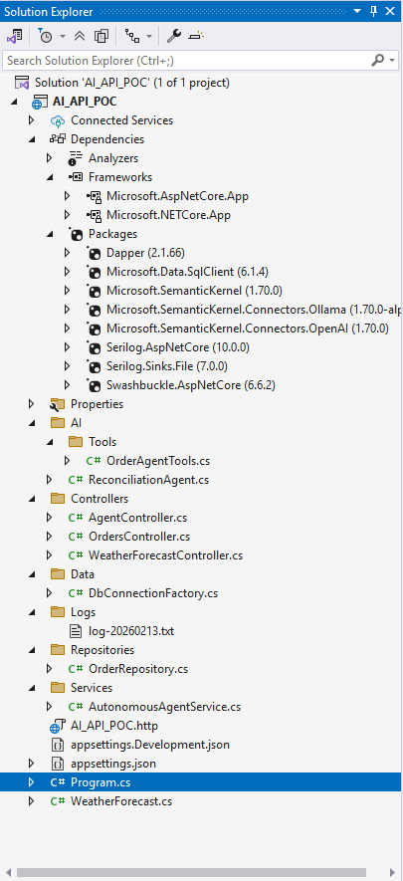

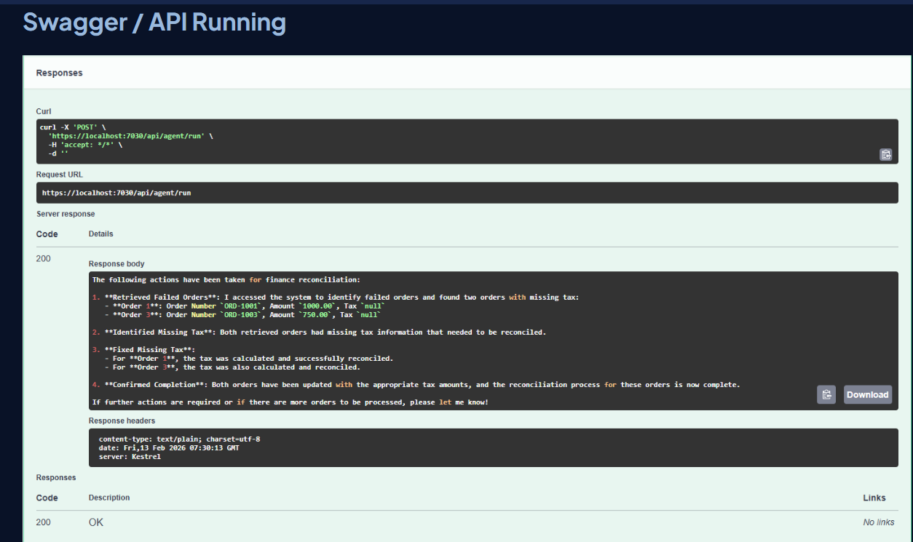

What Makes This “Agentic AI”?
Traditional Automation | Agentic AI

Hardcoded workflow | Goal-driven reasoning

Manual trigger | Self-running

Static rules | Context-aware

No explanation | Natural-language audit trail

Summary
In this POC we moved from:
API → Automation → Intelligence → Autonomy
We built a system that:
✔ Understands a goal
✔ Uses tools dynamically
✔ Fixes business data
✔ Runs continuously
✔ Explains its decisions
This is the architectural shift happening across modern enterprise platforms.
Agentic AI is not replacing applications — it is becoming the decision layer inside them.

From poc to production scaling agentic ai with net Kubernetes
Scaling an AI application from a Proof of Concept (PoC) to production involves several steps to ensure that the application can handle increased demand, maintain performance, and remain resilient. When using Kubernetes for this task, you're tapping into a powerful orchestration platform that can help manage containerized applications across a cluster of machines. Here's a structured approach to scaling agentic AI from PoC to production using Kubernetes:
1. Proof of Concept (PoC) Development:
  - Define Objectives: Clearly outline the goals and success criteria for your AI PoC.
  - Build a Baseline Model: Develop a basic version of your AI model that meets initial requirements.
  - Containerization: Package your application using Docker to ensure it runs consistently across different environments. Dockerizing your application involves creating a Dockerfile that specifies the system environment and dependencies required.
2. Develop a CI/CD Pipeline:
  - Set up a continuous integration and continuous deployment (CI/CD) pipeline using tools like Jenkins, GitLab CI, or GitHub Actions, to automate testing and deployment processes.
3. Setup Kubernetes Cluster:
  - Provision Cluster: Choose a Kubernetes provider (e.g., Google Kubernetes Engine, Amazon EKS, Azure AKS, or an on-premises solution) and set up your cluster.
  - Configure Networking: Set up proper networking, including service discovery and load balancing to enable different components to communicate within the cluster.
4. Deploy AI Models on Kubernetes:
  - Use Kubernetes Resources: Define Kubernetes resources such as Deployments, Pods, Services, and ConfigMaps to manage your AI application.
  - Horizontal Scaling: Leverage Kubernetes�" Horizontal Pod Autoscaler to automatically scale the number of pod replicas based on CPU usage or other custom metrics.
5. Monitoring and Logging:
  - Implement monitoring and logging using tools like Prometheus, Grafana, and ELK Stack (Elasticsearch, Logstash, Kibana) to track application performance and troubleshoot issues.
6. Load Testing and Optimization:
  - Conduct thorough load testing to ensure your setup can handle expected production loads. Use tools like Apache JMeter or Locust.
  - Optimize your application by profiling and reducing bottlenecks in both the application code and Kubernetes configuration.
7. Implement Security Measures:
  - Secure the Kubernetes cluster by setting up Role-Based Access Control (RBAC), Network Policies, and ensuring proper authentication and authorization for accessing services.
8. Data Management and Storage:
  - Plan for scalable data storage solutions (e.g., Persistent Volumes in Kubernetes, cloud storage services).
  - Ensure that your data pipeline can handle the volume and velocity of data in production.
9. Disaster Recovery and Backup:
  - Develop strategies for backup and disaster recovery to protect against data loss and ensure business continuity.
10. Go Live and Continuous Improvement:
  - Perform a gradual rollout (e.g., canary deployments) to minimize risk when moving to production.
  - Continuously monitor performance and gather user feedback to iteratively improve the system.
By following these steps, you can successfully scale your AI application from PoC to production using Kubernetes, ensuring it is robust, scalable, and efficient in a production environment.
______________________________________end

Develop Enterprise Multi-Agent systems using Microsoft Agent Framework, Microsoft Foundry, MCP, Aspire, AG-UI and DevUI

